# Project Plan Collaboration

Team Members: Kristina Mishra, Ritu Mundhe, and Keerthan Potturi

## Business Capability Model

McFarland has a vision of 3 core component areas: quality care, trusting relationships, and an exceptional workplace. As such, our business capability model (BCM) core business areas are defined by these values at level 0, with the individual capabilities that make these core areas possible listed at a level 1 below them. Quality Care is the number one value we strive to achieve at all times and involves all steps of customer interaction to McFarland for medical needs. Trusting relationships builds on the foundation of quality care by implementing processes that focus on building trust between McFarland, patients, the community, staff, and other entities that we work with to ensure superior care for our patients. The third core component that makes up our foundation is an exceptional workplace. McFarland believes that creating an exceptional environment for our staff results in the quality standards we promote. Exceptional workplace includes making sure our staff is trained, safe, and are top-rated talent.

Core components have to have enabling (i.e. supporting) business areas to succeed. Enabling business areas are defined by the capabilities that help support the core business areas. They are important drivers to deliver success, but may not be commonly thought of in our day-to-day interactions with our customers. It is noted that while the Information Tech capabilities are listed as an enabling business area vertically in our BCM in Image 1, they are more accurately described horizontally as they cross-apply to all capabilities.

In our BCM below, level 1 capabilities are categorized under the level 0 heading listed in lighter, corresponding colors. Where colors are red, this shows key opportunities for growth. Definitions of each capability are listed in Appendix A.

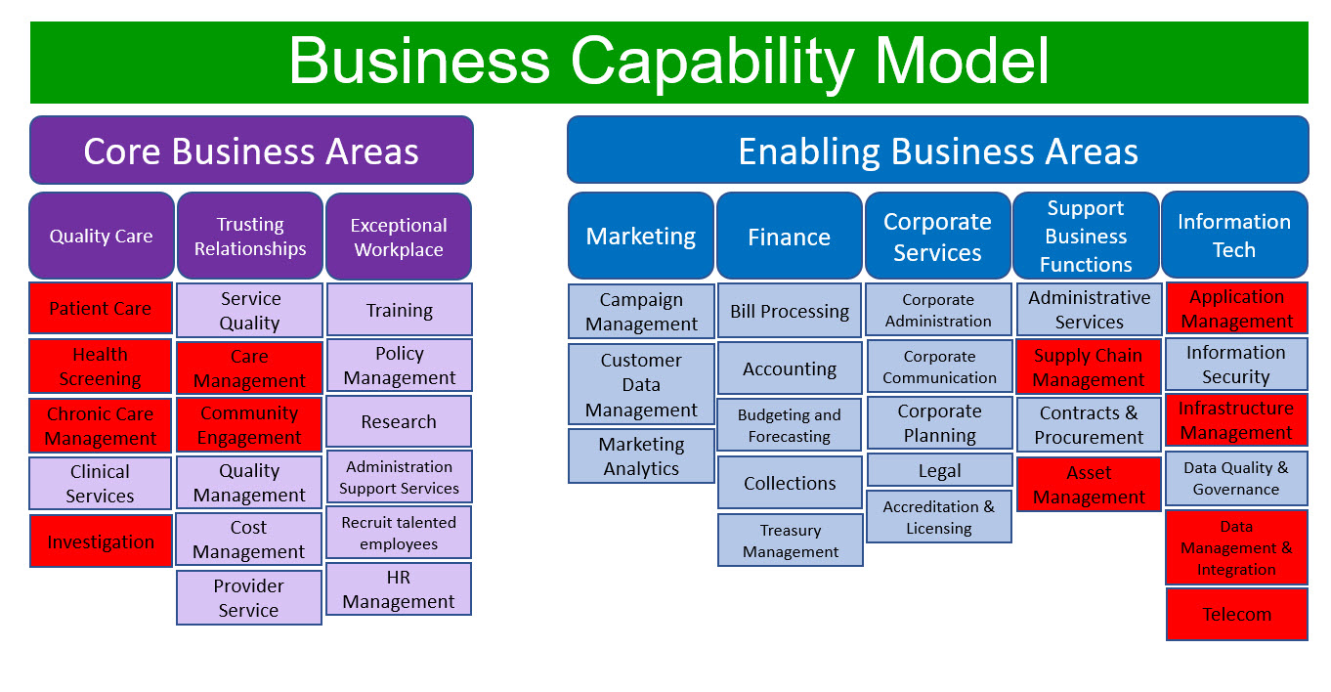

*Image 1: McFarland Business Capability Model*

## Core Diagram

When organizational units are tightly integrated around a standard set of processes, companies benefit from a Unification model. Companies applying this model find little benefit in business unit autonomy. They maximize efficiencies and customer services by presenting integrated data and driving variability out of business processes.[1] McFarland meets the qualifications of this model as many of their processes are standardized by federal, state, and insurance entity requirements. Patient data has its own set of requirements at similar levels, and where it does not have these requirements, it benefits McFarland to integrate this data at all levels within regulations. This expedites and provides a source of excellence in care that is part of the McFarland’s core capabilities model.

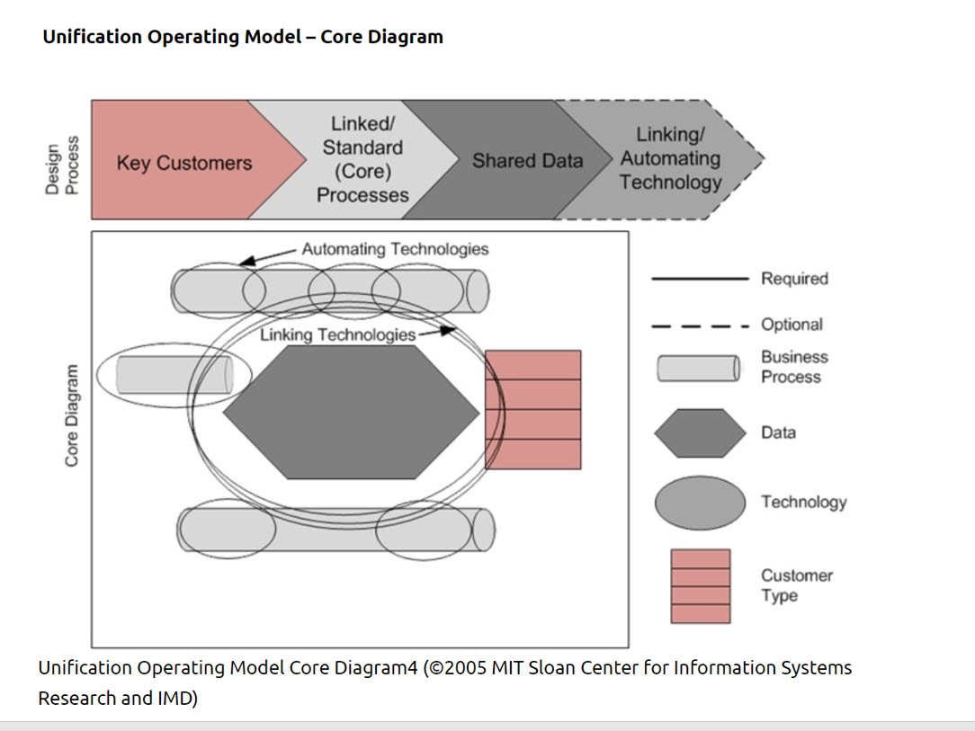

*Image 2: Unification Operating Model - Core Diagram*

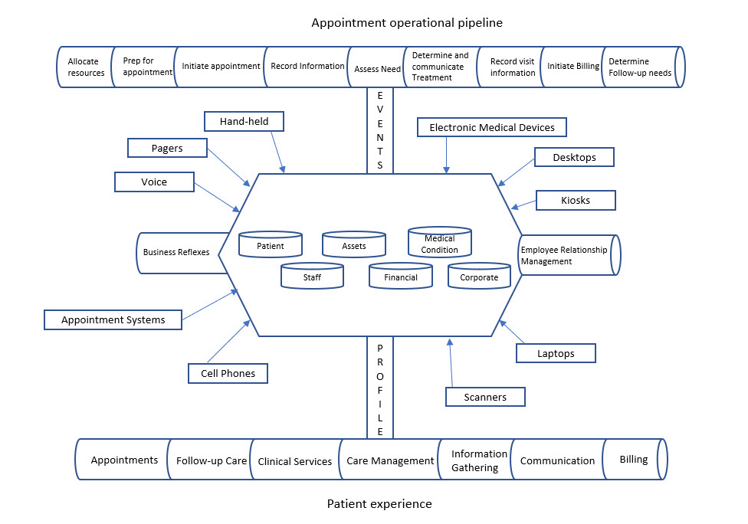

*Image 3: McFarland Core Diagram*

McFarland’s core processes center around providing medical care to patients. The McFarland core diagram in image 3 reflects this by displaying the processes of a patient’s experience as well as the pipeline processes involved in treating a patient. Data sources for integration are shown in the center hexagon as the key map in image 2 shows. As represented in the unification model, linking technologies are attached around the data center with both the employment management processes and business reflexes attached accordingly.

## Disruptions and Changes

### Major Disruptors

## 

*Image 4: based on 5 point disruptors from:* <https://www.forbes.com/sites/baininsights/2018/05/01/riding-the-disruption-wave-in-healthcare/#286ac2ae2846>

1. **Pandemic** - A large scale pandemic is an ever present threat to any industry, but it’s especially disruptive to the healthcare industry. A contagious disease can be accompanied by exponential patients admittance, laboratory testing costs, large requirement for medical supplies, sudden need for expansion of facilities, requirement of extensive telemedicine technology, and unforeseen demand of essential containment and safety equipment.
2. **The Amazon effect** - Big corporations like Amazon, Apple, Samsung are in the process of acquiring pharmaceutical licenses and are working on disrupting healthcare in yet-unspecified ways. These major players threaten to bring unprecedented technological revolution in the field of retail clinics, pharmacies and medical supplies and technology.
3. **Digital Revolution** - Technological change brings change in the methods, facilities and functions of operation. This makes the digital transformation a significant disruptor.
4. **Changing Regulations**  - Major legislative actions such as Affordable care act affect patient data storage and privacy requirements, and cost of covering medical equipment.
5. **Consumerism** - Increase in the number of choices including telemedicine and home care has caused decrease in consumer loyalty and will continue to create a threat.
6. **Personalized Medicine** - HCIT companies and biomarkers are developing health care solutions tailored to genetic makeup and history by using data from different sources.

The vision for McFarland must be proactive, progressive and competitive in order to withstand these disruptions. The opportunities noted in this SWOT analysis are at specific goals that must be incorporated in our IT strategy.

### SWOT Analysis and Vision

### 

### 

*Image 5: McFarland SWOT Analysis*

## Execution Gap

To close the execution gap we need to make IT strategies that are in line with McFarland’s core values. Our framework of a unification operating model suggests that our growth strategy should be centered on leveraging our existing products (medical care) in new markets (portal/app delivery).The attributes that need to be considered to implement this are to determine how our information technology (IT) capability can act as a catalyst horizontally across all capabilities. McFarland’s highest-ranking IT strategies are Customer Excellence and Financial Growth as shown in image 6.

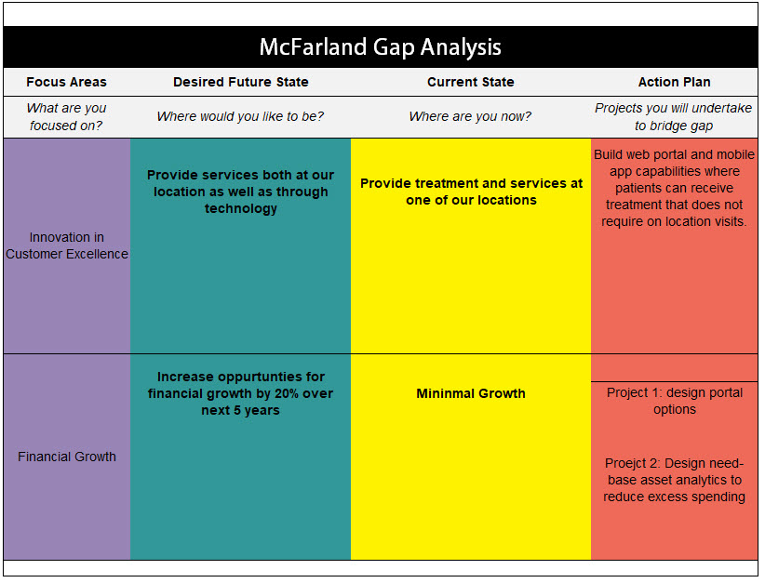

*Image 6: McFarland Gap Analysis Preliminary Examples*

### Competing with large corporations

Our disruptor analysis identified the threat called “The Amazon Effect”. We can use this threat as an opportunity and identify mechanisms we can use to have strategic partnership with these companies. Supply chain options through our portal can help solidify these partnerships and align us to partner on medical capabilities that are core to McFarland. We can further solidify these partnerships by using their need-based technologies, such as AWS, to decrease our gap between the current and future state.

The modern customer base tends to rely on the readily available online services rather than visits to a clinic. We must leverage this to our advantage by having robust digital capabilities accompanied by a strong market presence. Hence, marketing needs to be a in place for better traction and reach.

### COVID-19 Pandemic Response

COVID-10 Preparedness

As COOVID-19 continues to spread, it is essential we develop an online portal to address potential patient viral spread. This includes patients who may have symptoms of COVID-19 or other contagious diseases. An assessment can be made visually to determine further course of action. Following along the same lines, other viral spreads can be reduced by the portal, as well as protecting the community that may not need in-person visits, but still need medical attention.

Furthermore, we can address needs-based medical care of COVID-19 (and in general) with Project 2 of our Financial Growth strategy. While we still need to stockpile certain items for emergency services such as COVID-19, this will allow us to not have wasteful storage of unnecessary items during a pandemic or at other critical times. We must consider strategic partnerships to address the client need for online ordering and door-to-door delivery systems. In this way, patients can get the required treatment while remaining in quarantine, thus effectively helping to contain any outbreak.

Coordination with CDC

McFarland clinic must be ahead of the curve by working hand in hand with the CDC and Iowa Public Health Department. Our senior physicians and epidemic experts must act immediately on receiving indications from these organizations about any developments COVID-19 or any future outbreak. Regulatory changes are something we cannot predict but we can have a contingency plan based on the pattern of the regulatory changes in the past.

### Customized medicine and consumerism

Consumerism is a challenge that every industry is facing, and with the healthcare industry the same problem arises. With the number of digital platforms that provide service at the doorstep, McFarland will need to adopt this as their formal strategy to keep their current market as well as capture a new patient market previously unrealized.

Gene based customized (personalized) medicine can be a disruptor but if we can collaborate with the companies that manufacture them it can be a strength rather than a threat.

## Funding

Funding options come from 4 primary sources: self-funding, strategic partnerships, governmental options, and potential charitable funds. The bulk of funding is expected to be internal (self-funding) at 65%, but those costs are partially mitigated by the long-term benefits outlined below. The remaining funding is additionally explained in their respective categories below.

Self-funding includes premiums from selling excess assets and the increase in revenue that will be brought in with a larger patient base that will occur with easier access to medical care from the portal initiative. As we develop portal apps, we secure our patients’ safety for contagious issues, while at the same time not having to provide medical supplies, facilities, additional staff, etc. for patients that do not need to be seen in person. The increased specialized personnel required will bring in higher revenue without the costs normally associated with medical care. Patients are more likely to want to stay at home and get medical care when they are not feeling well, are in a vulnerable immune-suppressed sub-population, or where childcare may be difficult for a normal in-office visit.

Self-funding can further be addressed with downstream savings with the proposed needs-based system. This can include material supplies, locations, and personnel resources. By using data-driven methods, we can reduce supply stockpiles and share valuable resources that previously were very high in cost and infrequently used; particularly with portable medical equipment. This does not come without risk - supply shortages may cause temporary issues with supply-chain functions and cautions based on this risk need to be considered.

Strategic partnerships are expected to account for 20% of predicted costs. Partnerships include supply chain operations, cloud-based services, alignments with MedTech genetic companies, and 3rd party license agreements for medical related sale items that are not in-line with the McFarland’s business strategy. Supplier companies may have already invested in a bulk of the technology for needs-based systems that can absorb some of our costs, and moving to cloud-based solutions for many of our older servers are expected to reduce costs versus the replacement/upgrade costs that were previously expected. Partnerships with MedTech genetic companies for medical and diagnostic care and partnerships with our portal for at home medical delivery supplies, also fall into this category and will contribute to income revenue.

Government and private/charitable funding are expected to contribute to revenue from legislation mandates. Examples of past, present, and future funding in this category include James Zadroga 9/11 Health and Compensation Reauthorization Act, Medicare/Medicaid, potential further healthcare legislation and healthcare relief funding. Revenue and funding from these categories are expected to be 15%.

1. “Chapter 2” Enterprise Architecture for a Unification Model.” *Enterprise Architecture as Strategy: Creating a Foundation for Business Execution*, by Jeanne W. Ross et al., Harvard Business School Press, 2006, pp. 25–44.